**SP for program**

airs/xml/main_menu.php?view_user_id=-98909&CoupleconnectionId=345555&pgm_connectionId=345556

EXEC SP_Rel_lkp_RelSubType_ActiveList '211','List'

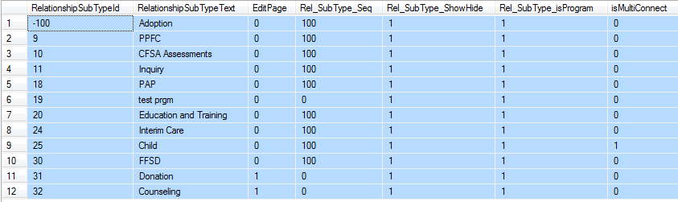

EXEC SP_CouplePrograms '211','-98909','345555'



**SP for Family links**

airs/xml/familylink.php?parentID=-98909&CoupleconnectionId=345555&RoleTypeId=-100&pgmConnectionId=345556

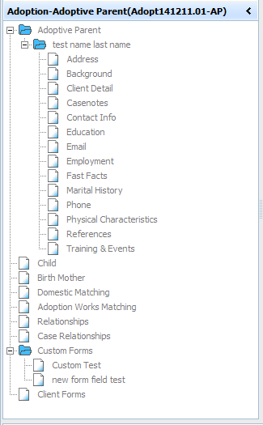

EXEC SP_ConnectionMemberList '211', 345556, 345555



EXEC SP_Rel_Quickconnect '211', '-100','-101'



EXEC SP_RelationshipSubTypeNPGM '211',default,default, 0

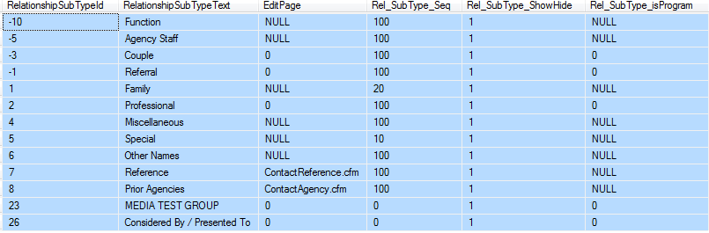

EXEC SP_RelationshipSubTypeALL '211','LIST','-100'



EXEC SP_ProgramRelList '211','345556','-100','1'

EXEC SP_RelationshipSubTypeNPGM '211',default,default, 0

**SP For status**

airs/xml/treegrid.php?uID=-98909

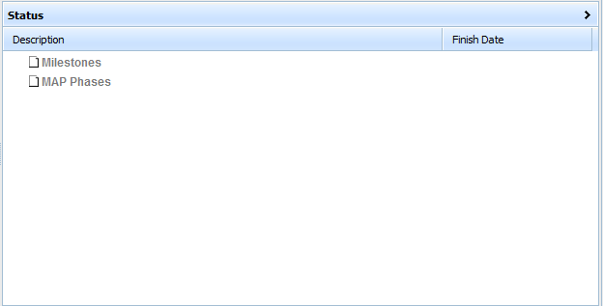

EXEC USP_GetStageHistory 98909

**SP For task**

airs/xml/followup.php?parentID=18192

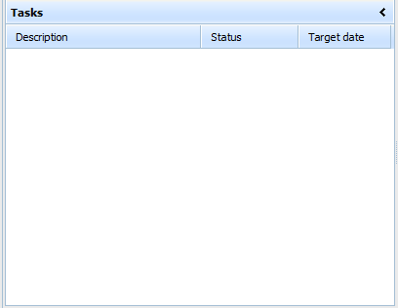

**No SP’s Found**

**Sp For contact info**

EXEC SP_EditContactInfo '211',98909, default,'Get'

